

**SMART DUSTBIN USING WIFI MODULE**

## A MINI PROJECT REPORT

***Submitted by***

|  |  |
| --- | --- |
| **DINESH .N** | **[20EC034]** |
| **DHAYALAN .N U** | **[20EC030]** |
| **DHARSAN .S** | **[20EC025]** |
| **BHUVANESHKUMAR .R** | **[20EC015]** |

**BACHELOR OF ENGINEERING**

## in

**COMPUTER AND COMMUNICATION ENGINEERING**

**Sri Eshwar College of Engineering**

**(An Autonomous Institution)**

**COIMBATORE – 641 202**

**MAY 2022**

**BONAFIDE CERTIFICATE**

Certified that this mini project report **“Smart Dustbin Using Wifi Module**” is the bonafide work of

|  |  |
| --- | --- |
| **DINESH .N** | **[20EC034]** |
| **DHAYALAN .N U** | **[20EC030]** |
| **DHARSAN .S** | **[20EC025]** |
| **BHUVANESHKUMAR .R** | **[20EC015]** |

who carried out the project work under my supervision

|  |  |
| --- | --- |
| …………………………………  **SIGNATURE**  **Dr. N. Shanmugasundaram,**  **M.E., Ph.D.,**  **HEAD OF THE DEPARTMENT**  Professor & Head,  Department of ECE,  Sri Eshwar College of Engineering,  Kinathukadavu,  Coimbatore-641202. | …………………………………  **SIGNATURE**  **Sakthi Kumar,**  **M.E.,Ph.D.,**  **SUPERVISOR**  Assistant Professor,  Department of ECE,  Sri Eshwar College of Engineering,  Kinathukadavu,  Coimbatore-641202. |

Submitted for the End Semesterpractical examination – Mini project work viva-voce held on _ _ _ _ _ _ _ _ _ _ _ _

……………………… ………………………

**(Internal Examiner) (External Examiner)**

ii

**TABLES OF CONTENTS**

|  |  |  |  |  |
| --- | --- | --- | --- | --- |
| **CHAPTER No.** | **TITLE** | | | **PAGE No.** |
|  | **ABSTRACT** | | | **iii** |
|  | **LIST OF TABLES** | | | **iv** |
|  | **LIST OF FIGURES** | | | **V** |
| **1** | **INTRODUCTION** | | | **1** |
| **2** | **LITERATURE SURVEY** | | | **4** |
|  | 2.1 | EXISTING PRODUCT | | 8 |
|  | 2.2 | PROBLEM STATEMENT | | 9 |
| **3** | **PROPOSED SOLUTION** | | | **10** |
|  | 3.1 | | OVERVIEW | 10 |
|  | 3.2 | | BLOCK DIAGRAM | 10 |
|  | 3.3 | | CIRCUIT DIAGRAM | 10 |
| **4** | **HARDWAE DESCRIPTION** | | |  |
|  | 4.1 | OVERVIEW | | 13 |
| **5** | **SOFTWARE DESCRIPTION** | | | 15 |
|  | 5.1 | PROCEDURE TO CREATE A PROJECT | | 17 |
|  | 5.2 | CODING STRUCTURE | | 18 |
| **6** | **RESULT AND IMPLEMENTATIONS** | | | **19** |
| **7** | **CONCLUSION AND FUTURE SCOPE** | | | **22** |
|  | **REFERENCE** | | | **23** |

## ABSTRACT

Every person in this world throws waste in the form of plastics, wet waste, dry waste and etc. Also, every person looks for a place or a plastic container to dispose that waste, that plastic container is the Dustbin which they look for. Dustbin is a plastic container where everyone can dispose their waste. Dustbin is used as a storage place to dispose waste, but we cannot estimate the exact amount of waste disposed by a society, and the dustbin cannot take more waste as the space should be available in it to take more. We need to know the level of waste in the dustbin and based on that we can intimate people to use the dustbin or not. In this Smart Dustbin project, we have designed a prototype where the lid of the dustbin is opened, on detection of human hand and waste, and the level of waste available inside the dustbin is sent as notification in the form of LED. The main components we used in making this prototype are Arduino, NODEMCU, Servo Motor and Ultrasonic Sensors. The software component is the application named as Blynk which is used to get notification. This dustbin can be a start to Smart Waste Management System where the officials can clean or empty the dustbin which depends on the notification received by them and not waiting for a call from a person of a society who informs the garbage trucks to come and take the waste from them.

iii

**LIST OF TABLES**

|  |  |  |
| --- | --- | --- |
| **TABLE NO** | **TITLE** | **PAGE NO** |
| 4.2 | COMPONENTS TABLE |  |

iv

**LIST OF FIGURES**

|  |  |
| --- | --- |
| **FIGURE NO** | **TITLE** |
| **Figure 3.21** | **BLOCK DIAGRAM** |
| **Figure 3.31** | **INTERFACING ARDUINO NANO WITH ULTRASONIC AND SERVO MOTOR.** |
| **Figure 3.32** | **INTERFACING NODEMCU(ESP8266) WITH ULTRASONIC SENSOR** |
| **Figure 4.11** | **NODE MCU (ESP8266)** |
| **figure 4.12** | **Servo motor** |
| **Figure 4.14** | **ARDUINO NANO** |
| **Figure 4.15** | **Jumper wires** |
|  |  |
|  |  |

V

**CHAPTER 1**

**INTRODUCTION**

Dustbin is the storage container used for disposing waste by each and every person in the world. The main thing they look in their surroundings for disposing waste is the Dustbin. Smart Dustbin is just a normal bin where everyone can dispose waste but integration of some hardware components is done for more efficient use of it. Smart Dustbin is integrated with some hardware components such as Arduino, NODEMCU, Servo Motor, Ultrasonic sensors. These components help in opening the lid, on detection of human hand and waste and also sending the notification in the form of LED. The code required to perform the above-mentioned operation is dumped in Arduino and NODEMCU.

The **smart dustbin** is a carefully designed solution that solves the social issue of waste disposal; the **smart dustbin** identifies the kind of material being thrown inside it and segregates it into bio or non-biodegradable. a smart bin is effective in public and social places as well. They are thoughtfully designed to store a large amount of garbage. These smart dustbins or containers are particularly useful in big cities. After the invention of innovative trash containers, the workload of municipalities is reduced. A smart dustbin is majorly helping in reducing waste included with waste elimination. A smart dustbin helps in the development of countries, places and regions. The city will become smarter if they are full of the smart bin. It is a cost-effective and eco-friendly solution that allows you to collect and reduce waste effectively. There are some benefits of using a smart bin.

**CHAPTER 2**

**LITERATURE SURVEY**

**2.1 EXISTING PRODUCT**

In this project, we will try to built an Internet of Things (IOT) based system will automatically notify and keep such garbage clean in a proper manner. Each and every person in the world disposes the waste in the dustbin and it full, they empty the waste inside the bin. This is the basic use of a normal dustbin where no components are used, no coding is performed, and everything is manual.

The maintenance of the bin is also not proper where the lid in the overflowing of the waste from the bin. The second method is use of dustbin with different segregations like green and blue bins which is placed together or the dustbin where only recyclable waste should be disposed. The third method uses arduino, servomotor, GSM module, ultrasonic sensor for doing the same result and it is not cost efficient. Ultrasonic sensors present inside the dustbin where the height of the waste inside the dustbin is measured and it send a mail when the dustbin is above 70 percent. Only sending the notification is the existing method.

First is the traditional method or the normal use of Dustbin in our daily life. Each and every person in the world disposes the waste in the dustbin and if the dustbin becomes full, he empties the waste inside the bin and again uses the same Dustbin. This is the basic use of a normal dustbin where no components are used, no coding is done and where everything is manual i.e. everything is done by hand. No batteries, no electronic components such as Arduino, NODEMCU are used.

* 1. **PROBLEM STATEMENT**
* A big challenge in the urban cities is solid waste management. The garbage collecting authority in traditional waste management system doesn’t know about the level of garbage in dustbin, if the dust bins gets full by garbage then it gets overflowed as well as spelled out from the dustbin leading to unhygienic condition in cities.
* People throw garbage on that dustbin which is already overflowed. Sometimes due to unclean garbage bins bad smell arises also toxic and unhygienic gases are produced which is way to support to the air pollution and to some harmful diseases which are easily spreadable. It is very bad look of the city. Use of traditional system result inefficient and time and money spending system

**CHAPTER 3**

**PROPOSED SOLUTION**

**3.1 OVERVIEW**

Smart Dustbin as its name represents it works smartly or we can say that it is an automatic dustbin. it works like when you will come in front of this dustbin it will open automatically with the help of a servo motor. so there is some sensor work to detect the object in front of the dustbin.

Smart Dustbin is a very good project from the Arduino board. it works likewise smart [things.](http://things.we/) we can say that, It is a decent gadget to make your home clean and attractive. due to practically all offspring of home consistently make it grimy and spread trash to a great extent by paper, rappers and numerous different [things.](http://things.kids/) kids have fun with this dustbin they play with the dustbin and in the play of them they clean your home as well because every time they use the smart Dustin and it attract the kids. they generally will be utilized to through all trash and waste into this smart dustbin.

Materials used in Smart Dustbin are:

* Ultrasonic Sensor
* Arduino
* Servo Moter S9
* Jumper Wire
* Battery or Power supply

**3.2 BLOCK DIAGRAM**

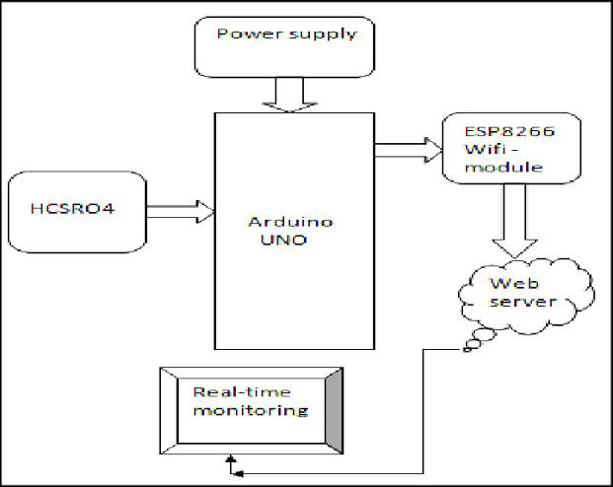

**ARDUINO**

**NANO**

**Figure 3.21 BLOCK DIAGRAM**

**3.3 CIRCUIT DIAGRAM**

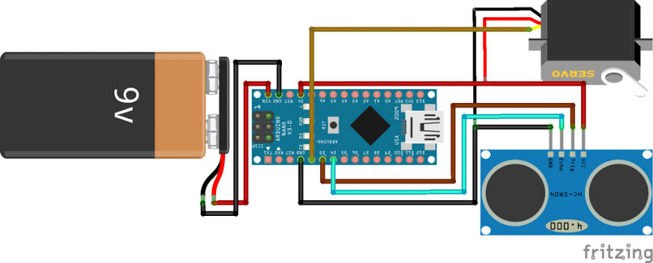

**Figure 3.31 INTERFACING ARDUINO NANO WITH ULTRASONIC AND SERVO MOTOR.**

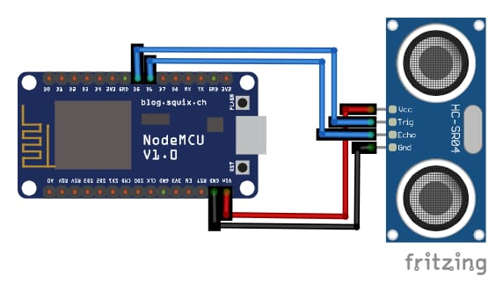

**Figure 3.32 INTERFACING NODEMCU(ESP8266) WITH ULTRASONIC SENSOR**

**CHAPTER 4**

**HARDWAE DESCRIPTION**

**4.1 OVERVIEW**

**1)NODE MCU (ESP8266):**

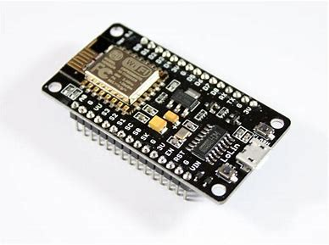

**Figure 4.11 shows the NODE MCU (ESP8266)**

In Node MCU is an open source IoT platform. This is used for making the things work using Wi-Fi. This board includes firmware which runs on ESP8266 Wi-Fi SoC Express Systems and the hardware is based on ESP-12 module. Node MCU is an open source firmware for which open source prototype board designs are available the name “NODE MCU” combines “node” and “MCU” (micro-controller unit).The term Node MCU strictly speaking refers to the firmware rather than the associated development kits.

**2)ULTRASONIC SENSOR:**

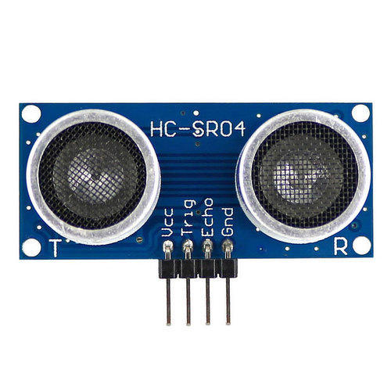

**Figure 4.12 -Ultrasonic Sensor**

Ultrasonic Sensor is an instrument which measures the distance to the waste using ultrasonic sound waves. It has a transducer that helps to send and receive ultrasonic pulses based on the object’s proximity. It detects the objects and the waste materials.

**3) SERVO MOTOR:**

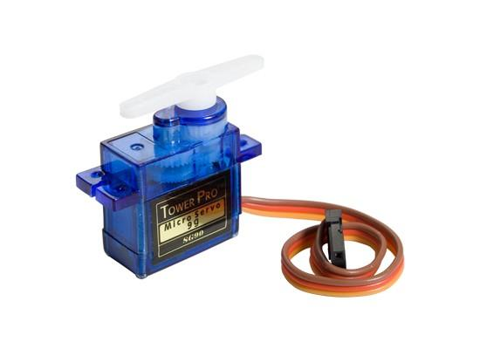

**Figure 4.13-Servo motor**

Servo Motor helps in opening the lid of the dustbin. The Arduino is programmed in such a way that after detecting the waste using ultrasonic sensor the lid should open automatically and this is done using this servo motor.

**4) Arduino NANO:**

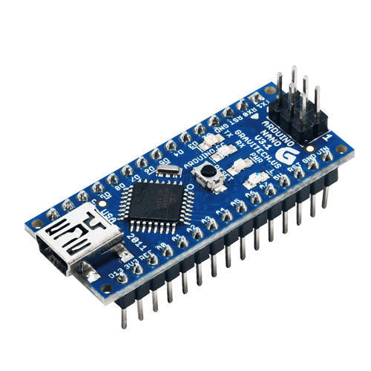

**Figure 4.14 ARDUINO NANO**

The Arduino Nano is a small, complete, and breadboard-friendly board based on the ATmega328 (Arduino Nano 3.x). It has more or less the same functionality of the Arduino Duemilanove, but in a different package. It lacks only a DC power jack, and works with a Mini-B USB cable instead of a standard one.

**5) JUMPER WIRES:**

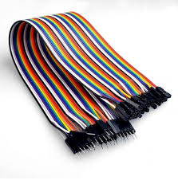

**Figure 4.15 Jumper wires**

Jumper wires are simply**wires that have connector pins at each end**, allowing them to be used to connect two points to each other without soldering. Jumper wires are typically used with breadboards and other prototyping tools in order to make it easy to change a circuit as needed.

**4.2 COMPONENTS TABLE:**

|  |  |  |
| --- | --- | --- |
| **S.NO** | **COMPONENTS** | **QUANTITY** |
| **HARDWARE COMPOENTS** | |  |
| **1)** | **ARDUINO NANO** | **1** |
| **2)** | **SERVO MOTOR** | **1** |
| **3)** | **ULTRASONIC SENSOR** | **2** |
| **4)** | **JUMPER WIRES** | **AS REQUIRED** |
| **5)** | **NODEMCU (ESP8266)** | **1** |
|  | **SOFTWARE COMPONENTS** |  |
| **1)** | **ARDUINO IDE** | **1** |
| **2)** | **BLYNK** | **1** |

**CHAPTER 5**

**SOFTWARE DESCRIPTION**

1. **Arduino IDE:**

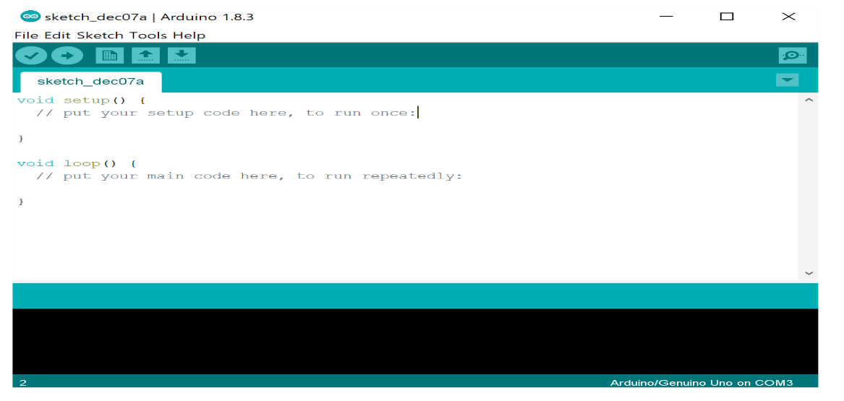

The software requirements for this project are Arduino IDE and Blynk app. Arduino IDE: The Arduino Integrated Development Environment is a cross platform application that is used to upload programs into Arduino Compatible boards. The Arduino IDE supports C and C++ using special rules of code structuring. The Arduino IDE employs the program AVRDUDE to convert the executable code into a text file in hexadecimal encoding that is loaded into the Arduino Board by a loader program in the board’s firmware. This IDE when selected opens a default sketch file where the part of the code is divided into two parts the void setup ( ) and the void loop ( ). Above these two statements the header files and the variable declarations should be done so that the actual code logic and be mentioned in those methods. The setup method has the different variables that are needed to perform the specific operation and the loop method consists the actual logic code. After the code has been written it should be verified and should be compatible to the board that the code needs to be uploaded.

**2)Blynk App:**

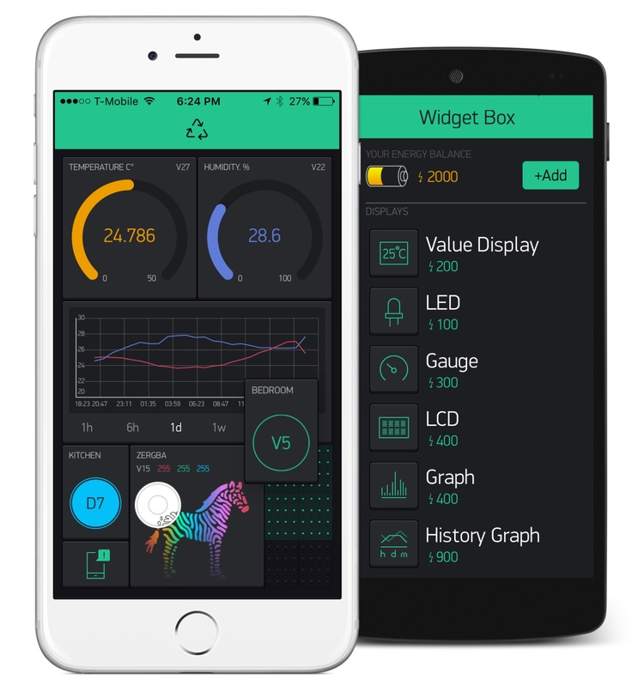

Blynk is a Platform with IOS and Android apps to control Arduino, Raspberry Pi and the likes over the Internet. It’s a digital dashboard where you can build a graphic interface for your project by simply dragging and dropping widgets.

|  |
| --- |
| **5.1 PROCEDURE TO CREATE A SMART DUSTBIN**  The prototype is constructed as follows:   * Taking a plastic container or a dustbin, placing an ultrasonic sensor at the front part of the dustbin. The lid of the dustbin is taken as a cardboard and a servo motor is placed on the lid. Another ultrasonic sensor is placed inside the dustbin. * The code of this project is divided into two parts. The first part code indicates the working of the dustbin i.e. mainly opening the lid of the dustbin. The second part code indicates the notification part which is received on the mobile using the Blynk app.   The first part is constructed as follows:   * The ultrasonic sensor placed at the front part has four pins named Vcc, GND, ECHO and TRIG. The pin TRIG, pin ECHO is connected to digital pin numbers two and three on the Arduino Board. The servo motor has three pins named Vcc, GND, and servo pin. The servo pin of Servo motor is connected to digital pin number nine on the Arduino board. * The Vcc of ultrasonic sensor is connected to 5V of Arduino board and the Vcc of servo motor is connected to 3.3V of Arduino board. The GND pins are connected to ground on the Arduino board. After the connections are made, the Arduino is connected to the system and using the Arduino IDE the code is dumped inside the Arduino. This ends the connection and code dump for the firstpart.   The second part is constructed as follows:   * The ultrasonic sensor which is placed inside the dustbin also has the same four pins named Vcc, GND, ECHO and TRIG. In the Arduino IDE the board has to be changed from Arduino UNO to NodeMCU, if the board is not available in the list then we need to install the board from the Boards Manager. * In this part the TRIG and ECHO pins of ultrasonic sensor is connected to digital pins D5 and D6 of NodeMCU. The Vcc is connected to Vin of NodeMCU and GND to ground of NodeMCU. This is the connection that is required and now the code should be dumped into NodeMCU. This ends the connection and code dump for the second part. |
| **5.2 CODING STRUCTURE** |

1. **INTERFACING ARDUINO WITH SERVO MOTOR AND ULTRASONIC SENSOR**

#include <Servo.h>   //servo library

Servo sg90;

int echo = 7;

int trig = 6;

int servopin = 8;

int distance;

int duration;

void setup() {

sg90.attach(8);

pinMode(trig, OUTPUT);

pinMode(echo, INPUT);

}

void loop() {

digitalWrite(trig,0);

delay(2);

digitalWrite(trig,1);

delayMicroseconds(10);

digitalWrite(trig,0);

duration = pulseIn(echo,1);

distance = duration*0.034/2;

if ( distance<30 ) {

sg90.write(0);

delay(4500);

Serial.print(distance);

}

else{

sg90.write(180);

delay(50);

}

}

1. **INTERFACING NODEMCU(ESP8266) WITH ULTRASONIC SENSOR USING BYLINK**

#define BLYNK_PRINT Serial

#include <ESP8266WiFi.h>

#include <BlynkSimpleEsp8266.h>

const int trigger = 9;

const int echo = 10;

float duration;

int distance, percentage;

const int upper_limit = 5;

const int bottom_limit = 80;

// You should get Auth Token in the Blynk App.

// Go to the Project Settings (nut icon).

char auth[] = "YourAuthToken";

// Your WiFi credentials.

// Set password to "" for open networks.

char ssid[] = "Your SSID ";

char pass[] = "Your PASSWORD";

void setup()

{

Serial.begin(9600);

pinMode(trigger, OUTPUT);

pinMode(echo, INPUT);

digitalWrite(trigger, LOW);

Blynk.begin(auth, ssid, pass);

}

void sensor()

{

digitalWrite(trigger, HIGH);

delayMicroseconds(10);

digitalWrite(trigger, LOW);

duration = pulseIn(echo, HIGH);

distance = duration * 0.017;

percentage= ((bottom_limit - distance)/(bottom_limit - upper_limit))*100;

//Actually percentage = (((bottom_limit - upper_limit)- (distance - upper_limit))/(bottom_limit - upper_limit)))*100;

}

BLYNK_READ(V5){

Blynk.virtualWrite(V5, percentage);

}

void loop()

{

sensor();

Blynk.run();

BLYNK_READ(V5);

}

**CHAPTER 6**

**RESULT AND IMPLEMENTATIONS**

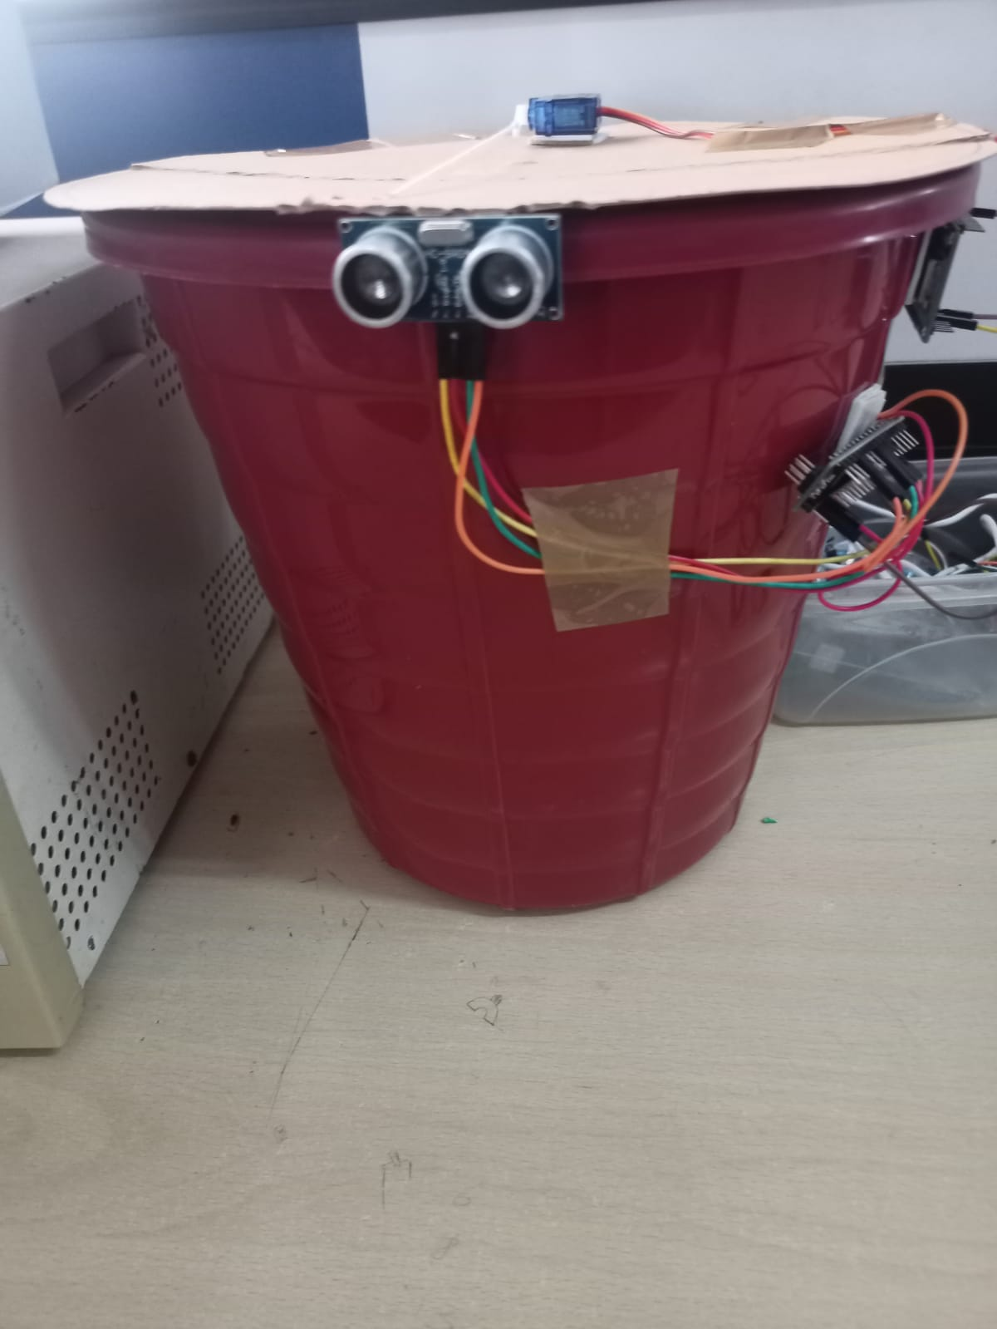

**CHAPTER 7**

**CONCLUSION AND FUTURE SCOPE**

IOT based Dustbins help the people to manage the waste easily and help them reduce the work of calling or waiting for the specific person to make the area clean and makes a heathier environment to live. They won’t be any kind of diseases and the people will be fit and are not prone to diseases caused by these waste materials. The mission Swachh Bharat can also be implemented easily. This system assures the cleaning of dustbins soon when the garbage level reaches its maximum. It will take power supply with the help of Battery. If the dustbin is not cleaned in specific time, then the record is sent to the Sweeper or higher authority who can take appropriate action against the concerned contractor. It ultimately helps in keeping the surrounding clean and the waste management can be much easier.

**FUTRURE SCOPE:**

There can be many enhancements done for this prototype which can be a revolutionary change in maintaining our environment clean and healthy. The few enhancements can be done are: The implementation of more collective bins placed side by side where it automatically detects the type and waste and places in the correct bin color which is assigned for that type. These dustbins can be placed with a GPS tracker where the dustbins in a particular locality can be located easily and the waste can be emptied. This method can lead to Smart Waste Monitoring System.

**REFERENCES**

1. https://circuitdigest.com/microcontroller-projects/iot-- smart-dustbin-using-esp8266
2. https://www.instructables.com/id/Smart-Home-ArduinoTrash-Indicator-With-BLE/
3. https://www.instructables.com/id/SMART-DUSTBINUsing-IoT/
4. S.S. Navghane, M.S. Killedar, Dr.V.M. Rohokale,‖ IoT Based Garbage and Waste Collection Bin‖, May 2016. <https://www.ijser.org/researchpaper/AN-IoT> BASEDSMART-DUSTBIN
5. Guerrero, L.A., Maas, G., Hogland, W.: Solid waste management challenges for cities in developing countries. Journal of Waste Management.
6. <https://www.elprocus.com/smart-dustbin-using-iot/>
7. https://www.youtube.com/watcv=9yrP1CZN3Ds